Стр.1

Схема расположения границ публичного сервитута на кадастровом плане территории кадастровых кварталов 28:01:110246, 28:01:110241, 28:01:110219. 28:01:110218, 28:01:110243, 28:01:110244, 28:01:110218, 28:01:110280, 28:01:110204, 28:01:110184, 28:01:110189, 28:01:110180, 28:01:110181, 28:01:110281, 28:01:110173, 28:01:110174, 28:01:110183, 28:01:110175, 28:01:110260, 28:01:110162, 28:01:110165, 28:01:110164, 28:01:030008, 28:01:030009, 28:01:030007, 28:01:010430, 28:01:010428, 28:01:010427.

Схема границ публичного сервитута на кадастровом плане (или кадастровой карте) территории
№п/п | Характеристики объекта и земельного участка |  | Объект расположен в пределах |  | Площадь границ сервитута (кв.м.) |  |  | Количество контуров на участке
1 | Категория земель:  Земли населенных пунктов  Цель установления публичного сервитута Эксплуатация объекта «Линия электропередач ВЛ-35 кВ Западная-Водозабор»  Местоположение:  Амурская область,  г. Благовещенск. |  | земельных участков:
1 |  |  | 28:01:110246:15 |  | 2 |  |  | 2
1 |  |  | 28:01:110246:818 |  | 1 |  |  | 1
1 |  |  | 28:01:110243:21 |  | 1 |  |  | 1
1 |  |  | 28:01:110244:8 |  | 1 |  |  | 1
1 |  |  | 28:01:110244:5 |  | 1 |  |  | 1
1 |  |  | 28:01:110244:142 |  | 1 |  |  | 1
1 |  |  | 28:01:110204:93 |  | 1 |  |  | 1
1 |  |  | 28:01:110204:191 |  | 1 |  |  | 1
1 |  |  | 28:01:110184:12 |  | 1 |  |  | 1
1 |  |  | 28:01:110184:51 |  | 1 |  |  | 1
1 |  |  | 28:01:110281:1 |  | 4 |  |  | 1
1 |  |  | 28:01:110173:32 |  | 1 |  |  | 1
1 |  |  | 28:01:110173:31 |  | 1 |  |  | 1
1 |  |  | 28:01:110174:30 |  | 1 |  |  | 1
1 |  |  | 28:01:110174:13 |  | 1 |  |  | 1
1 |  |  | 28:01:110174:12 |  | 1 |  |  | 1
1 |  |  | 28:01:110174:29 |  | 3 |  |  | 1
1 |  |  | 28:01:110175:33 |  | 1 |  |  | 1
1 |  |  | 28:01:110162:45 |  | 1 |  |  | 1
1 |  |  | 28:01:110165:106 |  | 1 |  |  | 1
1 |  |  | 28:01:110164:99 |  | 1 |  |  | 1
1 |  |  | 28:01:110164:114 |  | 1 |  |  | 1
1 |  |  | 28:01:030008:33 |  | 10 |  |  | 1
1 |  |  | 28:01:030009:72 |  | 3 |  |  | 1
1 |  |  | 28:01:030009:67 |  | 1 |  |  | 1
1 |  |  | 28:01:030007:331 |  | 1 |  |  | 1
1 |  |  | 28:01:030007:205 |  | 1 |  |  | 1
1 |  |  | 28:01:030007:207 |  | 1 |  |  | 1
1 |  |  | 28:01:030007:204 |  | 1 |  |  | 1
1 |  |  | 28:01:030007:203 |  | 1 |  |  | 1
1 |  |  | 28:01:000000:14172 |  | 2 |  |  | 2
1 |  |  | 28:01:010430:462 |  | 1 |  |  | 1
1 |  |  | 28:01:010430:134 |  | 1 |  |  | 1
1 |  |  | 28:01:010430:135 |  | 1 |  |  | 1
1 |  |  | 28:01:010428:38 |  | 1 |  |  | 1
1 |  |  | 28:01:010427:60 |  | 7 |  |  | 1
1 |  |  | 28:01:010427:59 |  | 1 |  |  | 1
1 |  |  | 28:01:010427:54 |  | 1 |  |  | 1
1 |  |  | 28:01:010427:58 |  | 4 |  |  | 1
1 |  |  | кадастровых кварталов:
1 |  |  | 28:01:110218 |  | 1 |  |  | 1
1 |  |  | 28:01:110243 |  | 2 |  |  | 2
1 |  |  | 28:01:110244 |  | 1 |  |  | 1
1 |  |  | 28:01:110218 |  | 15 |  |  | 3
1 |  |  | 28:01:110280 |  | 11 |  |  | 2
1 |  |  | 28:01:110204 |  | 40 |  |  | 13
1 |  |  | 28:01:110184 |  | 13 |  |  | 1
1 |  |  | 28:01:110189 |  | 4 |  |  | 4
1 |  |  | 28:01:110281 |  | 7 |  |  | 1
1 |  |  | 28:01:110173 |  | 3 |  |  | 1
1 |  |  | 28:01:110174 |  | 8 |  |  | 3
1 |  |  | 28:01:110175 |  | 2 |  |  | 2
1 |  |  | 28:01:110165 |  | 1 |  |  | 1
1 |  |  | 28:01:110164 |  | 1 |  |  | 1
1 |  |  | 28:01:030009 |  | 10 |  |  | 5
1 |  |  | 28:01:010430 |  | 1 |  |  | 1
1 |  |  | 28:01:010428 |  | 1 |  |  | 1
1 |  |  | 28:01:010427 |  | 57 |  |  | 4
Условный номер образуемого земельного участка: граница 1
Площадь образуемого земельного участка: 244 кв.м.
Обозначение характерных точек границ |  | Координаты, МСК-28 |  | Обозначение характерных точек границ |  | Координаты, МСК-28
 |  | X | Y |  |  | X | Y
1 |  | 2 | 3 | 1 |  | 2 | 3
граница 1
Граница1(1) |  | – | – | Граница1(16) |  | – | –
1 |  | 454605.63 | 3284006.95 | 52 |  | 454876.24 | 3282185.19
2 |  | 454607.37 | 3284001.61 | 53 |  | 454881.06 | 3282184.91
3 |  | 454601.76 | 3284000.00 | 54 |  | 454881.00 | 3282183.91
4 |  | 454600.08 | 3284005.31 | 55 |  | 454876.18 | 3282184.19
1 |  | 454605.63 | 3284006.95 | 52 |  | 454876.24 | 3282185.19
Граница1(2) |  | – | – | Граница1(17) |  | – | –
5 |  | 454567.93 | 3284105.58 | 56 |  | 454927.52 | 3281990.52
6 |  | 454571.55 | 3284104.03 | 57 |  | 454927.66 | 3281989.53
7 |  | 454570.18 | 3284100.17 | 58 |  | 454923.07 | 3281988.87
8 |  | 454566.47 | 3284101.69 | 59 |  | 454922.93 | 3281989.86
5 |  | 454567.93 | 3284105.58 | 56 |  | 454927.52 | 3281990.52
Граница1(3) |  | – | – | Граница1(18) |  | – | –
9 |  | 455414.29 | 3281278.43 | 60 |  | 454520.89 | 3284183.36
10 |  | 455417.09 | 3281272.71 | 61 |  | 454523.99 | 3284182.26
11 |  | 455411.46 | 3281273.88 | 62 |  | 454520.89 | 3284180.48
9 |  | 455414.29 | 3281278.43 | 60 |  | 454520.89 | 3284183.36
Граница1(4) |  | – | – | Граница1(19) |  | – | –
12 |  | 455528.35 | 3280053.96 | 63 |  | 454667.09 | 3283911.90
13 |  | 455533.28 | 3280050.95 | 64 |  | 454667.84 | 3283909.97
14 |  | 455528.10 | 3280048.68 | 65 |  | 454665.92 | 3283909.21
12 |  | 455528.35 | 3280053.96 | 66 |  | 454665.16 | 3283911.14
Граница1(5) |  | – | – | 63 |  | 454667.09 | 3283911.90
15 |  | 455368.15 | 3281369.85 | Граница1(20) |  | – | –
16 |  | 455371.37 | 3281365.59 | 67 |  | 455174.68 | 3281596.20
17 |  | 455365.90 | 3281364.70 | 68 |  | 455174.68 | 3281595.19
15 |  | 455368.15 | 3281369.85 | 69 |  | 455173.68 | 3281595.19
Граница1(6) |  | – | – | 70 |  | 455173.68 | 3281596.20
18 |  | 454923.05 | 3281905.35 | 67 |  | 455174.68 | 3281596.20
19 |  | 454928.37 | 3281904.95 | Граница1(21) |  | – | –
20 |  | 454925.17 | 3281900.90 | 71 |  | 455536.38 | 3280197.27
18 |  | 454923.05 | 3281905.35 | 72 |  | 455536.38 | 3280196.27
Граница1(7) |  | – | – | 73 |  | 455535.37 | 3280196.27
21 |  | 455545.11 | 3280342.91 | 74 |  | 455535.37 | 3280197.27
22 |  | 455546.45 | 3280337.93 | 71 |  | 455536.38 | 3280197.27
23 |  | 455541.91 | 3280339.50 | Граница1(22) |  | – | –
21 |  | 455545.11 | 3280342.91 | 75 |  | 454971.08 | 3282422.34
Граница1(8) |  | – | – | 76 |  | 454971.77 | 3282421.61
24 |  | 454536.67 | 3284128.80 | 77 |  | 454971.04 | 3282420.92
25 |  | 454533.96 | 3284124.66 | 78 |  | 454970.35 | 3282421.65
26 |  | 454531.86 | 3284128.73 | 75 |  | 454971.08 | 3282422.34
24 |  | 454536.67 | 3284128.80 | Граница1(23) |  | – | –
Граница1(9) |  | – | – | 79 |  | 454963.46 | 3282504.53
27 |  | 454929.94 | 3282856.12 | 80 |  | 454963.68 | 3282503.56
28 |  | 454934.12 | 3282853.33 | 81 |  | 454962.70 | 3282503.33
29 |  | 454929.91 | 3282851.55 | 82 |  | 454962.48 | 3282504.31
27 |  | 454929.94 | 3282856.12 | 79 |  | 454963.46 | 3282504.53
Граница1(10) |  | – | – | Граница1(24) |  | – | –
30 |  | 454944.40 | 3283026.13 | 83 |  | 454882.39 | 3282238.46
31 |  | 454946.37 | 3283022.74 | 84 |  | 454883.39 | 3282238.39
32 |  | 454941.96 | 3283022.52 | 85 |  | 454883.32 | 3282237.39
30 |  | 454944.40 | 3283026.13 | 86 |  | 454882.32 | 3282237.46
Граница1(11) |  | – | – | 83 |  | 454882.39 | 3282238.46
33 |  | 454888.50 | 3282297.25 | Граница1(25) |  | – | –
34 |  | 454889.40 | 3282296.81 | 87 |  | 454940.43 | 3282324.12
35 |  | 454886.76 | 3282291.27 | 88 |  | 454941.27 | 3282323.56
36 |  | 454885.86 | 3282291.71 | 89 |  | 454940.70 | 3282322.73
33 |  | 454888.50 | 3282297.25 | 90 |  | 454939.87 | 3282323.29
Граница1(12) |  | – | – | 87 |  | 454940.43 | 3282324.12
37 |  | 454762.04 | 3283262.94 | Граница1(26) |  | – | –
38 |  | 454763.19 | 3283260.79 | 91 |  | 455536.09 | 3279977.84
39 |  | 454761.12 | 3283259.66 | 92 |  | 455536.09 | 3279976.84
40 |  | 454759.89 | 3283261.79 | 93 |  | 455535.09 | 3279976.84
37 |  | 454762.04 | 3283262.94 | 94 |  | 455535.09 | 3279977.84
Граница1(13) |  | – | – | 91 |  | 455536.09 | 3279977.84
41 |  | 454674.96 | 3283858.07 | Граница1(27) |  | – | –
42 |  | 454675.96 | 3283855.99 | 95 |  | 455309.52 | 3281437.60
43 |  | 454673.88 | 3283854.99 | 96 |  | 455309.52 | 3281436.60
44 |  | 454672.88 | 3283857.06 | 97 |  | 455308.52 | 3281436.60
41 |  | 454674.96 | 3283858.07 | 98 |  | 455308.52 | 3281437.60
Граница1(14) |  | – | – | 95 |  | 455309.52 | 3281437.60
45 |  | 455722.65 | 3280374.58 | Граница1(28) |  | – | –
46 |  | 455726.75 | 3280377.96 | 99 |  | 454735.65 | 3283418.92
47 |  | 455726.75 | 3280370.98 | 100 |  | 454735.65 | 3283417.92
45 |  | 455722.65 | 3280374.58 | 101 |  | 454734.65 | 3283417.92
Граница1(15) |  | – | – | 102 |  | 454734.65 | 3283418.92
48 |  | 455652.96 | 3280638.40 | 99 |  | 454735.65 | 3283418.92
49 |  | 455655.06 | 3280633.97 | Граница1(29) |  | – | –
50 |  | 455654.16 | 3280633.55 | 103 |  | 454711.93 | 3283720.93
51 |  | 455652.06 | 3280637.97 | 104 |  | 454711.93 | 3283719.92
48 |  | 455652.96 | 3280638.40 | 105 |  | 454710.93 | 3283719.92
 |  |  |  | 106 |  | 454710.93 | 3283720.93
 |  |  |  | 103 |  | 454711.93 | 3283720.93
Граница1(30) |  | – | – | Граница1(45) |  | – | –
107 |  | 454705.41 | 3283808.51 | 167 |  | 454719.34 | 3283634.23
108 |  | 454705.41 | 3283807.51 | 168 |  | 454719.34 | 3283633.23
109 |  | 454704.41 | 3283807.51 | 169 |  | 454718.34 | 3283633.23
110 |  | 454704.41 | 3283808.51 | 170 |  | 454718.34 | 3283634.23
107 |  | 454705.41 | 3283808.51 | 167 |  | 454719.34 | 3283634.23
Граница1(31) |  | – | – | Граница1(46) |  | – | –
111 |  | 455582.04 | 3279560.16 | 171 |  | 455558.75 | 3280901.35
112 |  | 455582.04 | 3279559.16 | 172 |  | 455558.75 | 3280900.35
113 |  | 455581.04 | 3279559.16 | 173 |  | 455557.75 | 3280900.35
114 |  | 455581.04 | 3279560.16 | 174 |  | 455557.75 | 3280901.35
111 |  | 455582.04 | 3279560.16 | 171 |  | 455558.75 | 3280901.35
Граница1(32) |  | – | – | Граница1(47) |  | – | –
115 |  | 455487.70 | 3281086.15 | 175 |  | 455453.57 | 3281179.35
116 |  | 455487.70 | 3281085.15 | 176 |  | 455453.57 | 3281178.36
117 |  | 455486.70 | 3281085.15 | 177 |  | 455452.57 | 3281178.36
118 |  | 455486.70 | 3281086.15 | 178 |  | 455452.57 | 3281179.35
115 |  | 455487.70 | 3281086.15 | 175 |  | 455453.57 | 3281179.35
Граница1(33) |  | – | – | Граница1(48) |  | – | –
119 |  | 455660.56 | 3280362.50 | 179 |  | 455572.62 | 3279632.07
120 |  | 455660.56 | 3280361.49 | 180 |  | 455572.62 | 3279631.07
121 |  | 455659.56 | 3280361.49 | 181 |  | 455571.62 | 3279631.07
122 |  | 455659.56 | 3280362.50 | 182 |  | 455571.62 | 3279632.07
119 |  | 455660.56 | 3280362.50 | 179 |  | 455572.62 | 3279632.07
Граница1(34) |  | – | – | Граница1(49) |  | – | –
123 |  | 455064.20 | 3281746.58 | 183 |  | 455670.77 | 3280581.28
124 |  | 455064.20 | 3281745.58 | 184 |  | 455670.77 | 3280580.28
125 |  | 455063.20 | 3281745.58 | 185 |  | 455669.77 | 3280580.28
126 |  | 455063.20 | 3281746.58 | 186 |  | 455669.77 | 3280581.28
123 |  | 455064.20 | 3281746.58 | 183 |  | 455670.77 | 3280581.28
Граница1(35) |  | – | – | Граница1(50) |  | – | –
127 |  | 454939.47 | 3282944.04 | 187 |  | 455543.74 | 3279910.68
128 |  | 454939.47 | 3282943.04 | 188 |  | 455543.74 | 3279909.68
129 |  | 454938.47 | 3282943.04 | 189 |  | 455542.74 | 3279909.68
130 |  | 454938.47 | 3282944.04 | 190 |  | 455542.74 | 3279910.68
127 |  | 454939.47 | 3282944.04 | 187 |  | 455543.74 | 3279910.68
Граница1(36) |  | – | – | Граница1(51) |  | – | –
131 |  | 454914.94 | 3283066.39 | 191 |  | 455709.11 | 3280449.73
132 |  | 454914.94 | 3283065.39 | 192 |  | 455709.11 | 3280448.73
133 |  | 454913.94 | 3283065.39 | 193 |  | 455708.11 | 3280448.73
134 |  | 454913.94 | 3283066.39 | 194 |  | 455708.11 | 3280449.73
131 |  | 454914.94 | 3283066.39 | 191 |  | 455709.11 | 3280449.73
Граница1(37) |  | – | – | Граница1(52) |  | – | –
135 |  | 454725.87 | 3283535.89 | 195 |  | 454948.50 | 3282656.75
136 |  | 454725.87 | 3283534.89 | 196 |  | 454948.50 | 3282655.75
137 |  | 454724.87 | 3283534.89 | 197 |  | 454947.50 | 3282655.75
138 |  | 454724.87 | 3283535.89 | 198 |  | 454947.50 | 3282656.75
135 |  | 454725.87 | 3283535.89 | 195 |  | 454948.50 | 3282656.75
Граница1(38) |  | – | – | Граница1(53) |  | – | –
139 |  | 454938.81 | 3282754.68 | 199 |  | 455589.74 | 3279492.59
140 |  | 454939.73 | 3282754.31 | 200 |  | 455589.74 | 3279491.59
141 |  | 454939.35 | 3282753.37 | 201 |  | 455588.74 | 3279491.59
142 |  | 454938.43 | 3282753.76 | 202 |  | 455588.74 | 3279492.59
139 |  | 454938.81 | 3282754.68 | 199 |  | 455589.74 | 3279492.59
Граница1(39) |  | – | – | Граница1(54) |  | – | –
143 |  | 454623.43 | 3283972.51 | 203 |  | 454901.13 | 3282090.77
144 |  | 454623.43 | 3283971.51 | 204 |  | 454902.06 | 3282090.39
145 |  | 454622.43 | 3283971.51 | 205 |  | 454901.68 | 3282089.47
146 |  | 454622.43 | 3283972.51 | 206 |  | 454900.75 | 3282089.85
143 |  | 454623.43 | 3283972.51 | 203 |  | 454901.13 | 3282090.77
Граница1(40) |  | – | – | Граница1(55) |  | – | –
147 |  | 455541.95 | 3279394.65 | 207 |  | 455431.44 | 3279331.08
148 |  | 455541.95 | 3279393.65 | 208 |  | 455431.44 | 3279330.08
149 |  | 455540.95 | 3279393.65 | 209 |  | 455430.44 | 3279330.08
150 |  | 455540.95 | 3279394.65 | 210 |  | 455430.44 | 3279331.08
147 |  | 455541.95 | 3279394.65 | 207 |  | 455431.44 | 3279331.08
Граница1(41) |  | – | – | Граница1(56) |  | – | –
151 |  | 455521.38 | 3280995.06 | 211 |  | 454527.26 | 3284154.25
152 |  | 455521.38 | 3280994.05 | 212 |  | 454527.26 | 3284153.25
153 |  | 455520.38 | 3280994.05 | 213 |  | 454526.26 | 3284153.25
154 |  | 455520.38 | 3280995.06 | 214 |  | 454526.26 | 3284154.25
151 |  | 455521.38 | 3280995.06 | 211 |  | 454527.26 | 3284154.25
Граница1(42) |  | – | – | Граница1(57) |  | – | –
155 |  | 454884.19 | 3283105.67 | 215 |  | 455433.55 | 3279287.82
156 |  | 454884.19 | 3283104.67 | 216 |  | 455433.55 | 3279286.82
157 |  | 454883.19 | 3283104.67 | 217 |  | 455432.55 | 3279286.82
158 |  | 454883.19 | 3283105.67 | 218 |  | 455432.55 | 3279287.82
155 |  | 454884.19 | 3283105.67 | 215 |  | 455433.55 | 3279287.82
Граница1(43) |  | – | – | 166 |  | 455531.48 | 3280124.45
159 |  | 455550.42 | 3279841.87 | 163 |  | 455532.48 | 3280124.45
160 |  | 455550.42 | 3279840.87 | Граница1(58) |  | – | –
161 |  | 455549.42 | 3279840.87 | 219 |  | 455687.09 | 3280525.42
162 |  | 455549.42 | 3279841.87 | 220 |  | 455687.09 | 3280524.42
159 |  | 455550.42 | 3279841.87 | 221 |  | 455686.09 | 3280524.42
Граница1(44) |  | – | – | 222 |  | 455686.09 | 3280525.42
163 |  | 455532.48 | 3280124.45 | 219 |  | 455687.09 | 3280525.42
164 |  | 455532.48 | 3280123.45
165 |  | 455531.48 | 3280123.45
166 |  | 455531.48 | 3280124.45
163 |  | 455532.48 | 3280124.45
Граница1(59) |  | – | – | Граница1(65) |  | – | –
223 |  | 455238.43 | 3281521.51 | 247 |  | 455072.52 | 3281709.61
224 |  | 455238.43 | 3281520.51 | 248 |  | 455073.01 | 3281708.74
225 |  | 455237.43 | 3281520.51 | 249 |  | 455072.14 | 3281708.25
226 |  | 455237.43 | 3281521.51 | 250 |  | 455071.65 | 3281709.11
223 |  | 455238.43 | 3281521.51 | 247 |  | 455072.52 | 3281709.61
Граница1(60) |  | – | – | Граница1(66) |  | – | –
227 |  | 455626.02 | 3280714.46 | 251 |  | 455600.26 | 3280350.65
228 |  | 455626.02 | 3280713.46 | 252 |  | 455600.26 | 3280349.65
229 |  | 455625.02 | 3280713.46 | 253 |  | 455599.26 | 3280349.65
230 |  | 455625.02 | 3280714.46 | 254 |  | 455599.26 | 3280350.65
227 |  | 455626.02 | 3280714.46 | 251 |  | 455600.26 | 3280350.65
Граница1(61) |  | – | – | Граница1(67) |  | – | –
231 |  | 455558.82 | 3279771.56 | 255 |  | 455590.08 | 3280809.47
232 |  | 455558.82 | 3279770.55 | 256 |  | 455590.08 | 3280808.48
233 |  | 455557.83 | 3279770.55 | 257 |  | 455589.08 | 3280808.48
234 |  | 455557.83 | 3279771.56 | 258 |  | 455589.08 | 3280809.47
231 |  | 455558.82 | 3279771.56 | 255 |  | 455590.08 | 3280809.47
Граница1(62) |  | – | – | Граница1(68) |  | – | –
235 |  | 454956.95 | 3282578.65 | 259 |  | 455539.71 | 3280262.57
236 |  | 454957.74 | 3282578.04 | 260 |  | 455539.71 | 3280261.58
237 |  | 454957.13 | 3282577.25 | 261 |  | 455538.71 | 3280261.58
238 |  | 454956.34 | 3282577.85 | 262 |  | 455538.71 | 3280262.57
235 |  | 454956.95 | 3282578.65 | 259 |  | 455539.71 | 3280262.57
Граница1(63) |  | – | – | Граница1(69) |  | – | –
239 |  | 454841.04 | 3283159.54 | 263 |  | 455136.15 | 3281638.35
240 |  | 454841.82 | 3283158.91 | 264 |  | 455136.79 | 3281637.58
241 |  | 454841.19 | 3283158.14 | 265 |  | 455136.03 | 3281636.95
242 |  | 454840.41 | 3283158.77 | 266 |  | 455135.39 | 3281637.71
239 |  | 454841.04 | 3283159.54 | 263 |  | 455136.15 | 3281638.35
Граница1(64) |  | – | – | Граница1(70) |  | – | –
243 |  | 454979.80 | 3282346.44 | 267 |  | 455566.76 | 3279703.10
244 |  | 454980.21 | 3282345.53 | 268 |  | 455567.18 | 3279702.21
245 |  | 454979.30 | 3282345.12 | 269 |  | 455566.27 | 3279701.79
246 |  | 454978.89 | 3282346.03 | 270 |  | 455565.86 | 3279702.69
243 |  | 454979.80 | 3282346.44 | 267 |  | 455566.76 | 3279703.10

Стр.5
Схема расположения границ публичного сервитута на кадастровом плане территории кадастровых кварталов 28:01:110246, 28:01:110241, 28:01:110219. 28:01:110218, 28:01:110243, 28:01:110244, 28:01:110218, 28:01:110280, 28:01:110204, 28:01:110184, 28:01:110189, 28:01:110180, 28:01:110181, 28:01:110281, 28:01:110173, 28:01:110174, 28:01:110183, 28:01:110175, 28:01:110260, 28:01:110162, 28:01:110165, 28:01:110164, 28:01:030008, 28:01:030009, 28:01:030007, 28:01:010430, 28:01:010428, 28:01:010427.

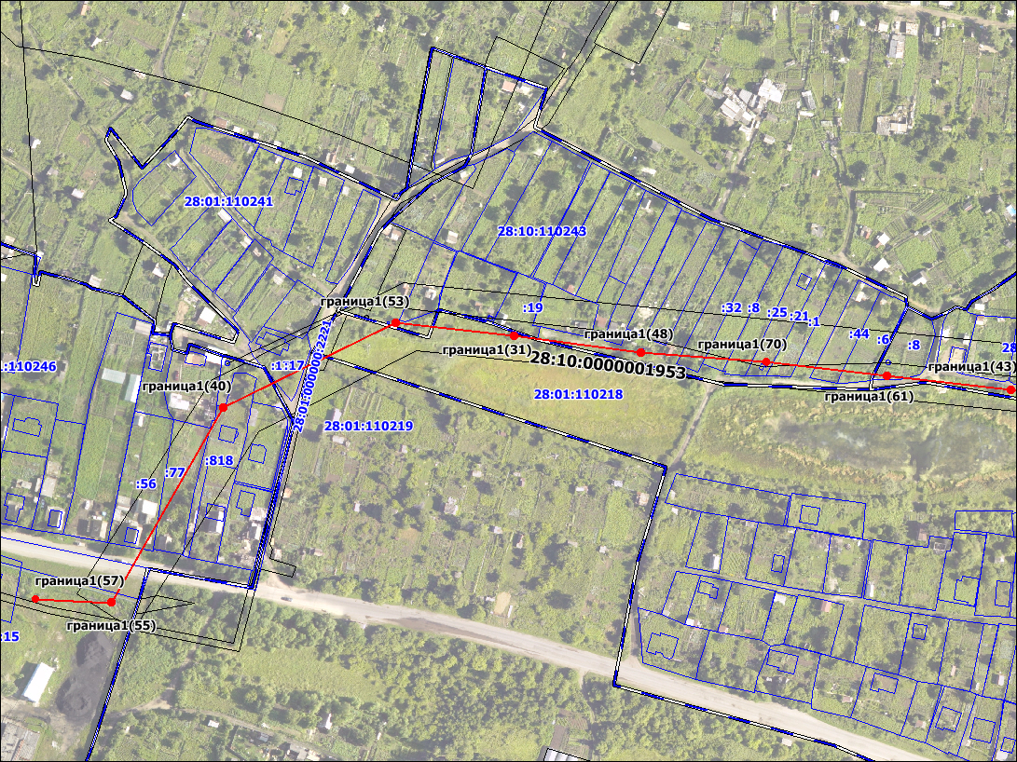

Стр.6

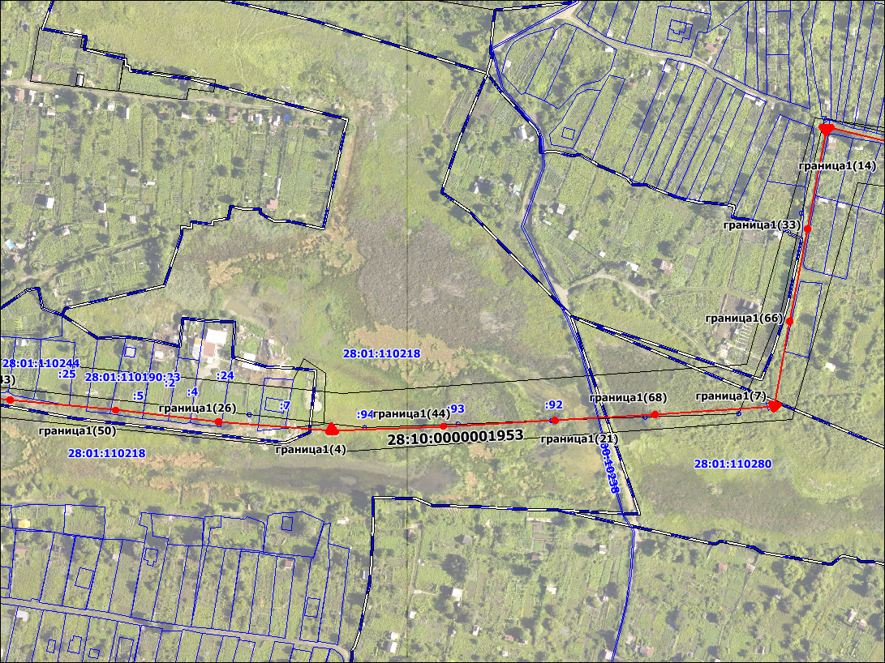

Стр.7

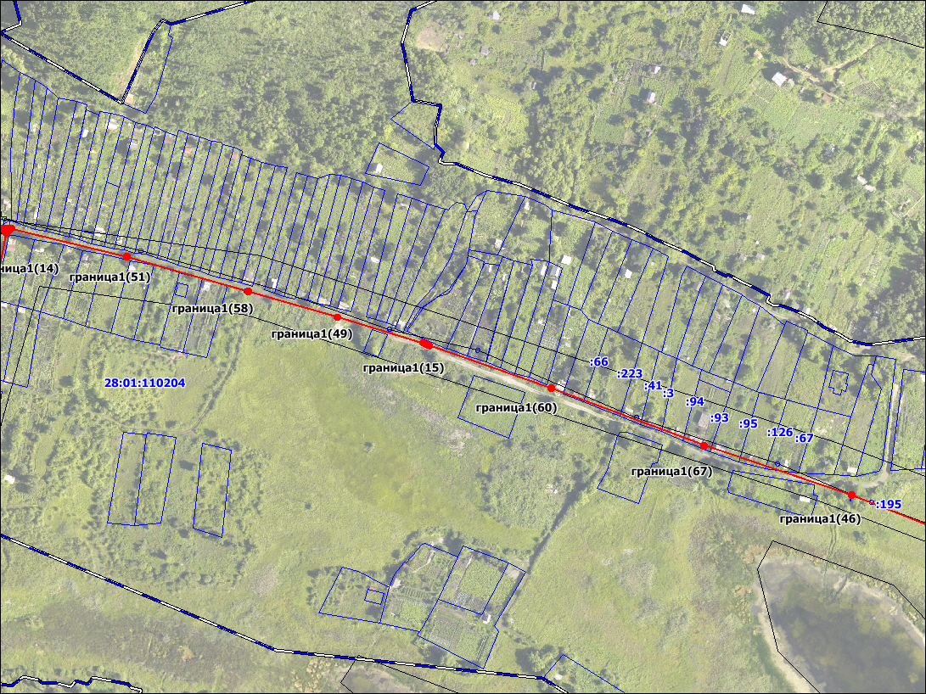

Стр.8

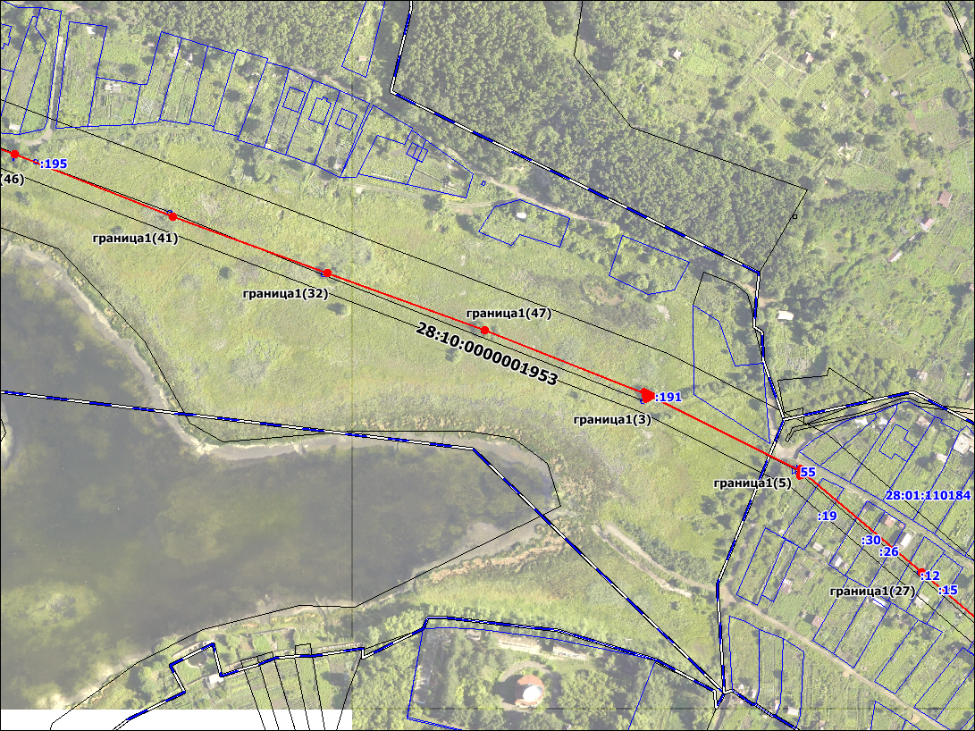

Стр.9

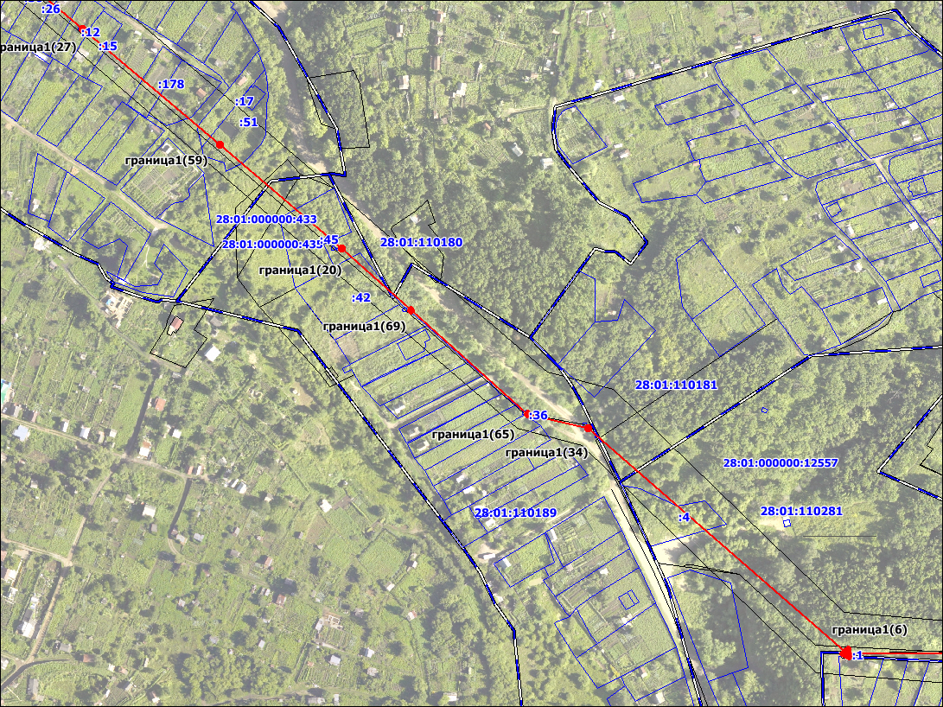

Стр.10

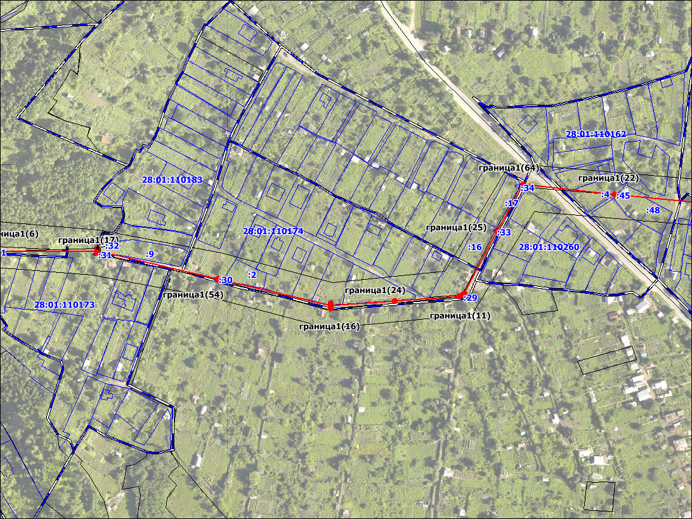

Стр.11

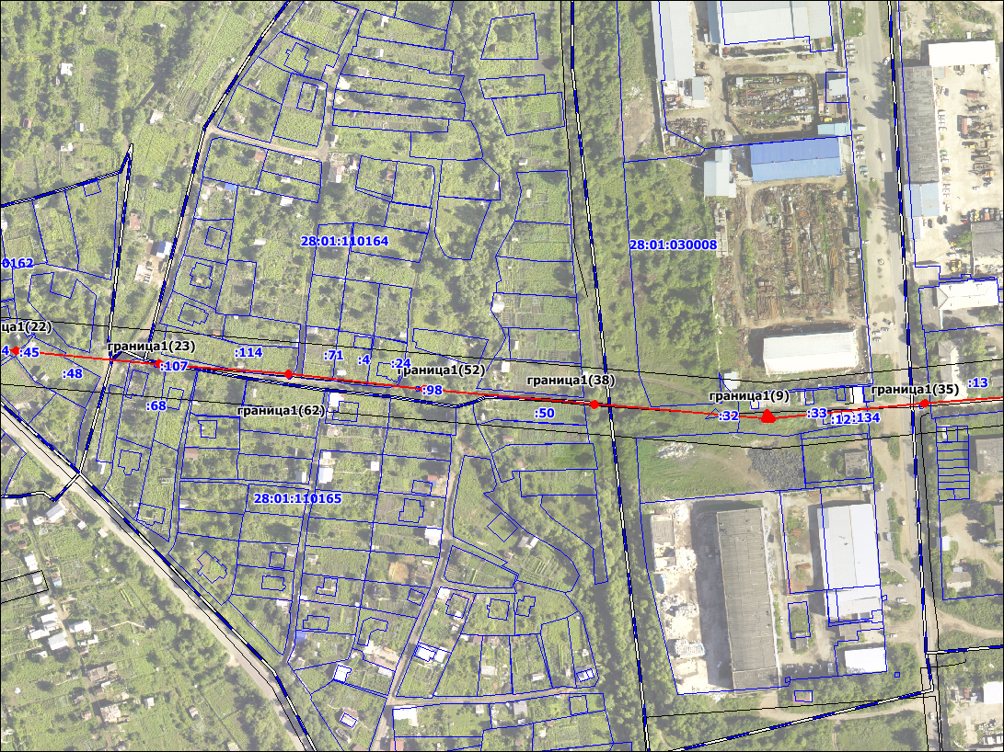

Стр.12

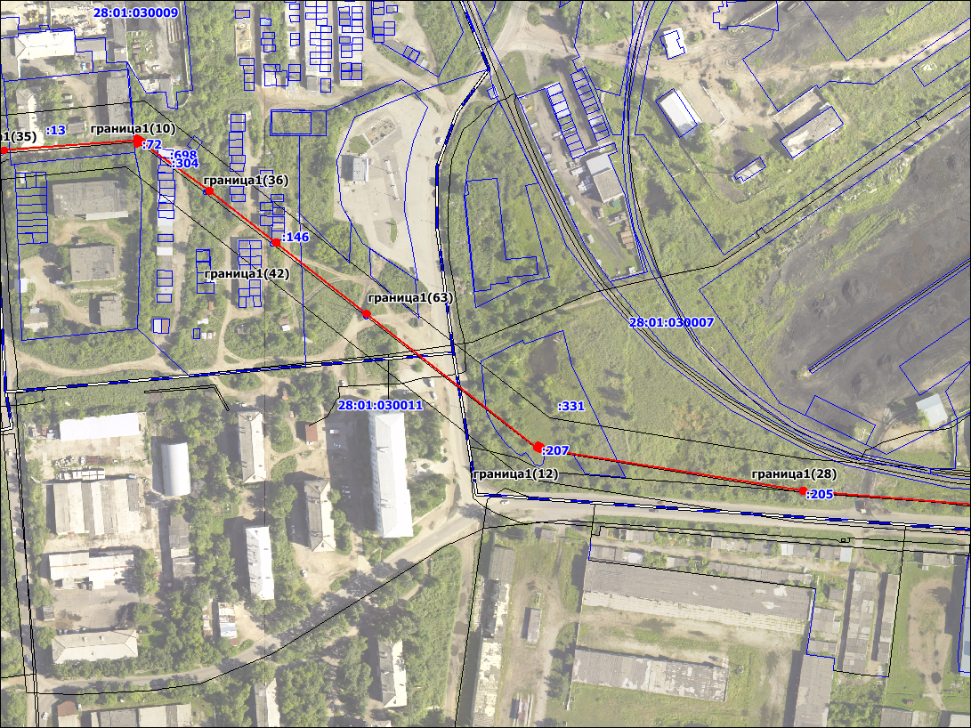

Стр.13

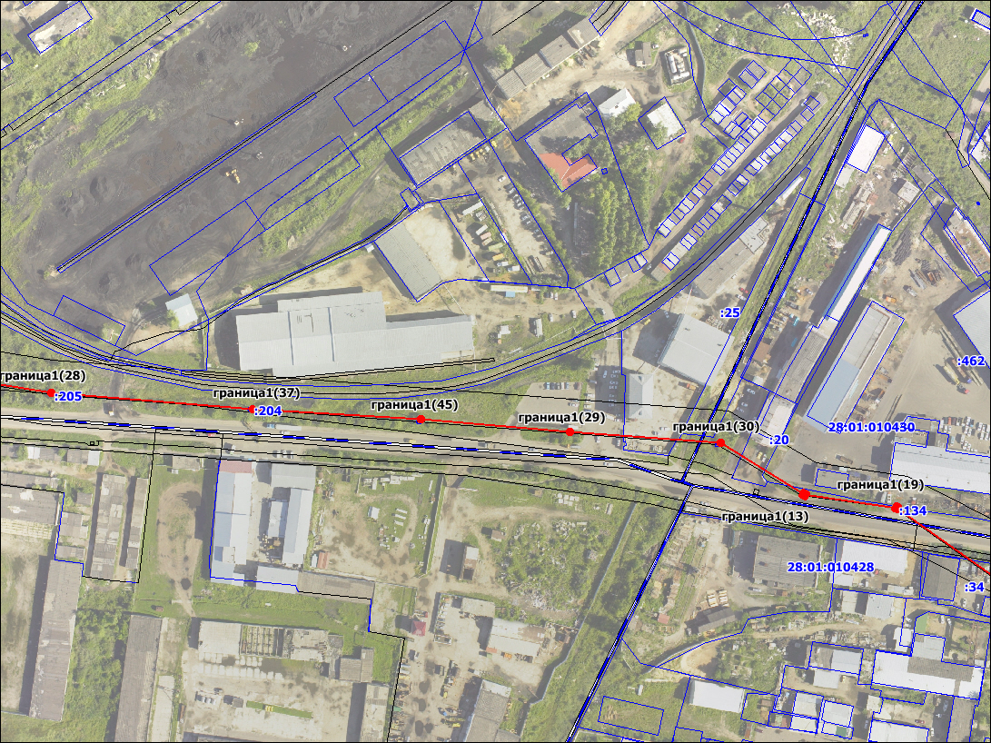

Стр.14

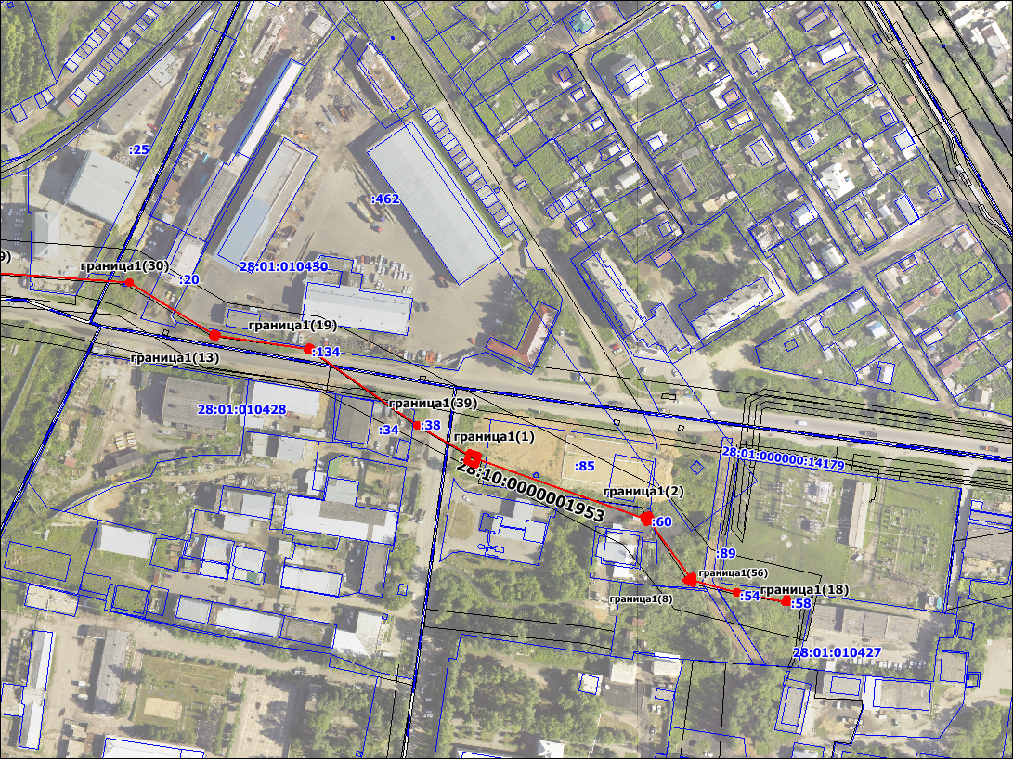

Масштаб 1: 2 500

Система координат: МСК-28

Условные обозначения:
_______ - граница контура, образуемая в результате работ
:11 - номер земельного участка по сведениям ГКН
граница 1 - обозначение границы, являющегося объектом работ

Кадастровый инженер _________________________________________________С.И. Лукашевич
№ квалификационного аттестата кадастрового инженера 28-11-79

